**The Perfect Pair**

**Key Contributors:**

**Jackie Picon Gabe Ream**



**2/7/2022**

This project and the preparation of this report were funded in part by ….through an agreement with the University of the Incarnate Word.

Cyber Security Systems and the University of the Incarnate Word

## EXECUTIVE SUMMARY

In this project we’ll be creating a website to sell socks. We will implement cloud resources and services. We’ll explain the process we went through when picking the tools and services used to create the backbone of our cloud computing infrastructure.

Project Milestones: E.g. Major steps required to complete your project.

1. Discuss project ideas and plan
2. Create website and implement cloud resources
3. Manage cloud resources and services

Deliverables: E.g. Report, Deployed architecture, other project outcomes etc.

1. Project Status Report
2. Deployed Architecture
3. Finalized Project
4. Project Presentation

Professional Accomplishments: E.g. New skills that you developed

1. Accomplishment 1
2. Accomplishment 2
3. Accomplishment 3

## PROJECT SCHEDULE MANAGEMENT

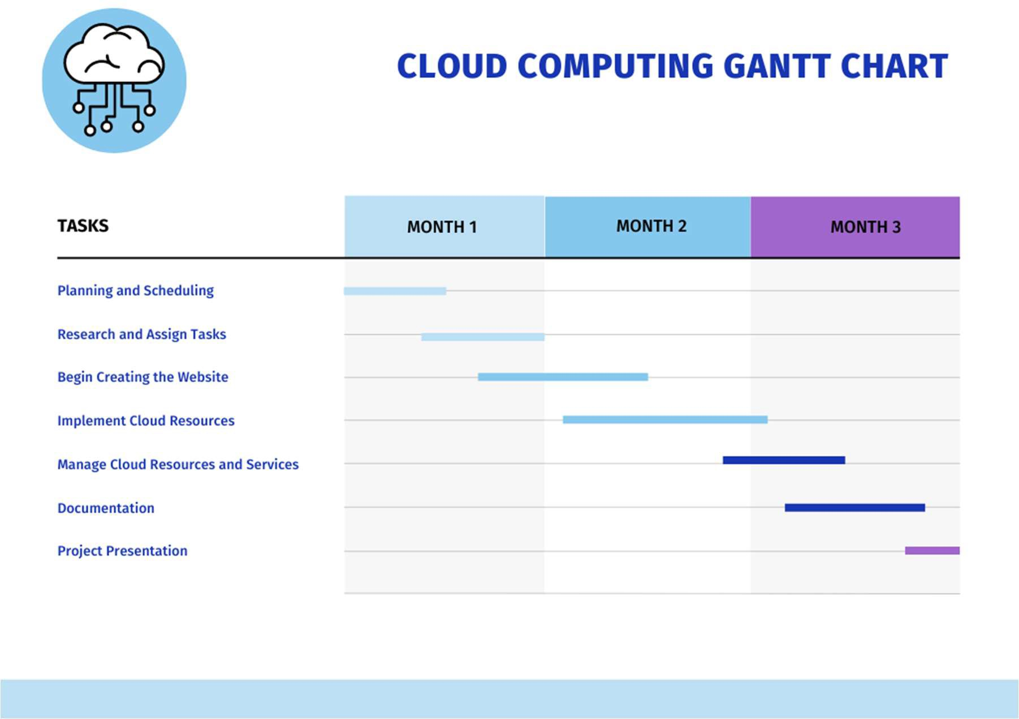

Project Management Board Link (QR Code Only). Send invite to user: @gonzalodparra



Create a Github Project Repository and add the user “cyberknowledge” as a contributor. [gabeream/Cloud-Computing-Project (github.com)](https://github.com/gabeream/Cloud-Computing-Project)

[Project | Trello](https://trello.com/b/A48TrzEH/project)

## TABLE OF CONTENTS

[List]

# [Cloud Computing Project]

## Load-balanced Wordpress Website

The first step in our project was creating a website. We decided to use Amazon Lightsail to create a load-balanced wordpress website. The load balancer distributes network traffic over a pool of servers, which improves the number of concurrent users our website can handle. This is important because we expect this sock business to really take off. Creating the wordpress website was not a short process. It involved: creating a MySQL managed database in Lightsail, creating an IAM user for the wordpress instance, connecting to the wordpress instance via SSH to configure the managed database and IAM user credentials, signing in to the dashboard of the website to install a WP Offload Media plugin, duplicating the wordpress instance, and creating the load balancer and attaching the wordpress instances.

The “first step in our first step” was launching and configuring the wordpress instance. This involved creating an instance, selecting the aws region and availability zone (Oregon and us-west-2a), choosing an instance image (Linux for the platform, wordpress for the blueprint), choosing a plan, and naming it. Next we connected to our instance via SSH and retrieved the password for our wordpress website. This was done through a series of commands using Bitnami wordpress. Then we signed in to the administration dashboard of our wordpress website, and created a lightsail static IP address and attached it to our wordpress instance. Then we created a lightsail DNS zone and mapped a domain to our wordpress instance.

**Creating a MySQL managed database**

Next we had to create a MySQL managed database. From lightsail, we went to the database section and created a new database. First we pick the region and availability zone and make them the same as the wordpress (us-west-2a). Then we chose MySQL 8.0.17 and the price plan. Then we marked down the database DNS name, username, and password.

**Creating an amazon S3 bucket**

We created an amazon S3 bucket to store the media from our wordpress website. First we went into the amazon S3 console and clicked block public access, including blocking it through access control lists (ACL’s). Then we clicked create bucket, which was only a couple steps.

**Creating an IAM policy and user for wordpress instance**

We created a policy for the amazon S3 bucket we made. Then we created an IAM user with the policy that can access the S3 bucket.

**Connect to the wordpress instance via SSH to configure the managed database and IAM user credentials**

We exported the data from the MySQL database on our wordpress instance. Then we imported it to the MySQL managed database in lightsail. Next we configured the wordpress instance to connect to the MySQL managed database. And finally, we configured the IAM user credentials in our wordpress instance.

**Install WP Offload Media plugin**

We installed the WP Offload Media plugin on our wordpress website. This plugin created an amazon S3 bucket in our aws account using the IAM credentials we had just configured in the previous step. It also connected our wordpress to the new S3 bucket so that media files uploaded to our website would be saved to the new S3 bucket. This S3 bucket serves as the central media file location for our wordpress instance.

**Duplicating our wordpress instance**

We created a snapshot of our wordpress instance, and then used the snapshot to create a duplicate of our instance.

**Create a load balancer and attach instance**

We clicked create a load balancer and went through the simple steps, selected our wordpress instance as the target instance.

**Connected to the MySQL database using Sqlectron**

We used Sqlectron to connect to the MySQL database. It also helped us work in our MySQL database.

**In conclusion**

All these steps are how we created the cloud infrastructure for our website. The final result was a customized website where we are able to view and edit the information from the website in our MySQL database.



***Significant takeaways / Boxed text***

**TITLE PAGE TITLE** (Calibri, 20 R: 0 G: 32 B: 96)

**Authors / Contributors** (Calibri, 20, RGB Hex: cb333b)(Logos can be used)

**Date** (Calibri, 20, RGB Hex: cb333b)

This project and the preparation of this report were funded in part by monies provided by CPS Energy through an agreement with The University of Texas at San Antonio.

CPS Energy and the University of Texas at San Antonio

**------------------------------------------------------------------------------------------------------------**

**-----------------**

**EXECUTIVE SUMMARY**(Cambria, 15.5 RGB Hex: 003960)

TEXT (Cambria, 12 Black)

Sub-Text (Calibri, 9.5 Black)

**TABLE OF CONTENTS** (Cambria, 15.5 RGB Hex: 003960

TEXT (Cambria, 12 Black)

Sub-Text (Calibri, 9.5 Black)

**------------------------------------------------------------------------------------------------------------**

**-----------------**

# SECTION HEADER

(SECTION HEADER: Cambria, 26 RGB Hex: 003960)

**HEADER 1** (Cambria, 15.5 RGB Hex: 003960)

**Header 2** (Cambria, 14 RGB Hex: 005a98)

Header 3 (Cambria, 13 RGB Hex: cb333b)

Body Text (Calibri, 10.5 Black)

***Boxed Text*** (Calibri, 9.5 Black Bold Italics)

*Letter of Transmittal Sample*

November 23,2021

University of The Incarnate Word Attention: Dr. Gonzalo. D. Parra 4301 Broadway

San Antonio, TX 78209 Dear Dr. Parra:

With this letter, the team

### CIS 3353 Final Project.

transmits the following items associated with the

### SCOPE OF WORK (dated 11/23/2021): “Title of Your Work”

* DELIVERABLES related to the

sub-task:

Aim 1:

Deliverable 1

Deliverable 2

Aim 2:

Deliverable 1

Deliverable 2

Please share these with your team as appropriate. If you have any questions, please contact at (210) 458-8618 or by email at .

Kindest regards,

Team Lead

Student of Cyber Security Systems at the University of the Incarnate Word